Abdullrahman Alghanim

02/20/2025

Module 6 lab 4

CIS 3367

Capture output from the lockdown file and it means that this security system is confidential and can not be accessed by anyone

Show the dmesg output, meaning the system has NX protection enabled, meaning it's better protected against certain types of malware and exploits that rely on executing code in non-executable memory regions.

Capture the current ASLR status.

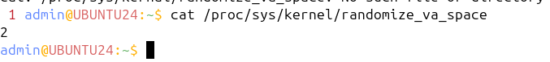

Capture the output confirming ASLR is set to ‘1’ then back to ‘2’

Capture the terminal output. The screenshot must show the bottom lines of the  
output of step 1 above, then the complete output of steps 2 and 3.

Capture the bottom of the output that shows the “rw-p” bits on the [stack]

Capture the dmesg output showing Seccomp is enabled

